Spring Boot with MongoDB

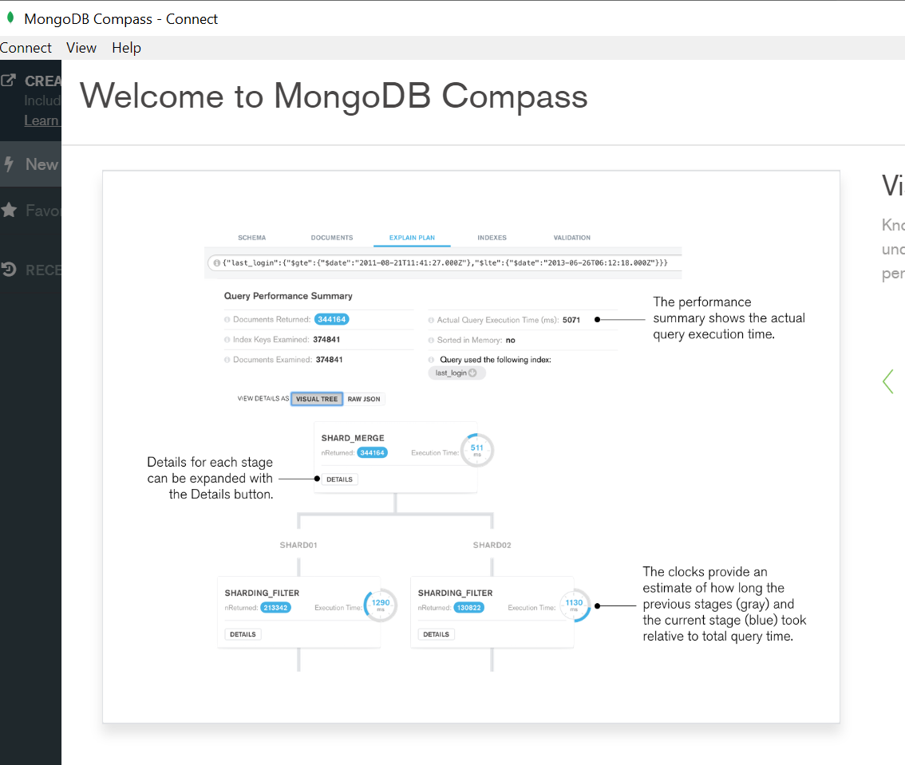

<https://www.guru99.com/installation-configuration-mongodb.html>

